**MedAppointments**

A Project Report

submitted in partial fulfillment of the requirements

of

Applied Cloud Computing For Software Development

by

### Sarguna Sundhari E , 822720106035

**Sivasankari E , 822720106042**

### Thanga Swetha M , 822720106044

**VISALI T , 822720106047**

Under the Esteemed Guidance of

## Mrs . Umamaheswari

### ACKNOWLEDGEMENT

My sincere gratitude to my supervisor Mrs. Umamaheswari for guiding us throughout the planning and development phase of the system . sincere guidance and always cooperating nature has provided us with proper knowledge and directions on how to prepare for final documentation . she motivated and encouraged use very time while selecting the proper project topic .

*ABSTRACT*

The purpose of the entitled as “MedAppointments” is to computerize the front office management of hospital to develop software which is user friendly simple , fast and cost effective.

It deals with the collection of patient information , diagnosis details etc . Traditionally it was done manually . the main function of the system is register and store patient details and doctor details and retrieve these details as and when required and also to manipulate these details meaningfully system input contains patient details.

Diagnosis details while system output is to get these details on to the screen the doctor appointment or receptionist . only they add into the database .

The data can be retrieved easily . the data are well protected for personal use and makes the data processing very fast .

It is a web based application it maintains records of patients , doctors , appointments and schedule that occur at any of the medical center.

It maintains two levels of users 1 administrator level and

2 user level

User level divided into two 1 patient level

2 doctor level

The proposed system has the following capabilities maintaining patients records , register new patients records of appointments and easy future reference .user and administrators can search records more easily .

The project has been developed in back-end : PHP , MySQL and front-end : HTML , CSS , JAVASCRIPT .the main motto of our project is to facilitate the people to take appointment easily , find doctors available schedule .

### TABLE OF CONTENTS

Abstract ..........................................................................................................................

List of Figures ..........................................................................................................................

List of Tables ..........................................................................................................................

**Chapter 1. Introduction**............................................................................................................. **1**

1.1 Problem Statement .......................................................................................... 1

1.2 Problem Definition ........................................................................................... 1

1.3 Expected Outcomes.......................................................................................... 1

1.4. Organization of the report 1

Chapter 2. Literature Survey .................................................................................................... 1

2.1 Brief Introduction of Paper .............................................................................. 1

2.2 Techniques Used In Paper ................................................................................ 1

Chapter 3. Proposed Methodology........................................................................................... 2

3.1 System Design ..................................................................................................... 2

3.2 Modules Used… ...................................................................................... 2

* 1. Data flow diagram 2
  2. Advantages
  3. Requirement Specification

Chapter 4. Implementation and Results .................................................................................. 4

4.1 Results of Face Detection........................................................................................

* 1. Results of Face Recognition
  2. Result of Concentration Analysis

**Chapter 5. Conclusion** ............................................................................................................... **5**

**Github Link......................................................................................................................**

**Video Link........................................................................................................................**

**References** .......................................................................................................................... **…..**

**LIST OF TABLES**

|  |  |
| --- | --- |
|  | **MEDAPPOINTMENTS** |
| **FIGURE 1** | LOGIN PAGE |
| **FIGURE 2** | ADMIN LOGIN |
| **FIGURE 3** | DOCTOR LOGIN |
| **FIGURE 4** | PATIENT LOGIN |
| **FIGURE 5** | SCHEDULE LOGIN PAGE |
| **FIGURE 6** | ACCURATE APPOINTMENT PAGE |
| **FIGURE 7** | ENHANCED SECURETY |
| **FIGURE 8** | DATA DRIVEN HEALTHCARE |
| **FIGURE 9** | IMPROVED ACCESSIBILITY |

## CHAPTER 1 INTRODUCTION

**CHAPTER 1 INTRODUCTION**

### Problem Statement:

The challenges is to streamline and simplify the process of scheduling doctor appointments for patients . traditional methods often involve time consuming phone calls and manual record keeping this project aims to create a digital solution that enhance the efficiency of appointments scheduling , reduces wait time , and improve overall patient experience.

### Problem Definition:

problem of manual appointing of patient . no information about the doctors availability and specialization at the clinic long waiting queue for taking appointments and no surety of getting it . clumsy prescription storage and losing it . no medical record , no health history , inconvenient time schedule of appointment , clinics do not have any record keeping system to check the progress and report of the clinic **.**

### Expected Outcomes:

Used Authentication , Doctor database , Appointment scheduling , Appointment reminders , patient history , Admin panel , secure data handling , user feedback .

### Organization of the Report : DEPLOYMENT:

1 . Choose hosting service

1. Environment configuration
2. Database deployment
3. Monitoring and scaling
4. Continuous deployment
5. Security consideration
6. Compliance with regulations
7. Testing .

## CHAPTER 2 LITERATURE SURVEY

**CHAPTER 2 LITERATURE SURVEY**

### Paper-1

**Robust Real-Time Face Detection by Paul Viola and Michael A. Jones, 2003**

### Brief Introduction of Paper:

The paper "Robust Real-Time Face Detection" by Viola and Jones (2003) introduced a landmark method for face detection. Their technique is based on Haar-like features and employs a cascade of classifiers to efficiently and accurately detect faces in real-time. The Viola-Jones algorithm is known for its speed and reliability, making it a foundational approach in computer vision applications

### Techniques used in Paper:

* + 1. **The Viola-Jones face detection algorithm introduced in the paper employs Haar-like features, integral images, and a cascaded classifier. Haar-like features represent local intensity patterns, and integral images facilitate rapid computation of these features. The cascade structure optimizes the process by quickly rejecting non-face regions, allowing the algorithm to focus computation on potential face areas. The combination**

**of these techniques results in an efficient and robust real-time face detection system**

## CHAPTER 3 PROPOSED METHODOLOGY

**CHAPTER 3 PROPOSED METHODOLOGY**

### System Design

System design is the process of defining the architecture , components , modules , interfaces , and data for a system to satisfy specified requirements . It helps in specifying hardware and system requirements and also helps in defining overall system architecture . the system design specification serve as input for next phase of the model . it includes interface design , data design , and process design . In user interface design I concerned with how users interact with the system add information to the system . and how the system will presents information back to the users . In data design it concerned with how the data is represented and stored within the system . finally , process design is concerned with how data moves through the system

. I show in DFD

* + 1. **Registration**:
    2. **Recognition:**

To enhance registration and recognition in a medical appointment system design, consider implementing secure user authentication, such as two-factor authentication or biometric verification, to ensure the identity of both patients and healthcare providers. Utilize a robust database system to store and manage patient information securely, adhering to data protection regulations.

Incorporate a user-friendly interface for easy registration, allowing patients to provide necessary information efficiently. Implement features like appointment reminders and notifications to enhance use

engagement. Additionally, consider integrating a recognition system for healthcare providers to streamline their access to patient records and facilitate a smoother workflow.

Ensure compliance with relevant healthcare standards and regulations to maintain the confidentiality and privacy of sensitive medical information throughout the system. Regularly update and test security measures to stay ahead of potential threats in the evolving landscape of healthcare technology.

### Modules Used

A software product implementation method is a systematically approach to effectively integrate software based service or component into the workflow of an organizational structure or an individual end user . the implementation on product is in a financial perspective of a major issue . the software can be able to access through the internet . I used to implement the software using given below .

### PHP

* **HTML**

### JAVA SCRIPT

* **MYSQL Face Detection:**

**USER AUTHENTICATION** : patient can create accounts , log in ,and manage their profiles .

**DOCTOR DATABASE** : implement a database to store details to doctors , including specialties , availability , and contact information .

**APPOINTMENT SCHEDULING** : Allow patients to view doctor availability and scheduling appointments at their convenience .

**APPOINTMENTS REMINDERS** : Implementations a remainder system to notify patients of upcoming appointments through emails and SMS .

**PATIENT HISTORY** : Maintain a record of patient appointment history making it easier for both patients and doctors to track medical visits .

**ADMIN PANEL** : Provides an admin interface for managing doctor details appointments schedules and resolving scheduling conflicts .

**SECURE DATA HANDLING** : Implements robust security measure to protect patient and doctors information .

**USER FEEDBACK** : Allow patients to provides feedback on their appointments facilities continuous improvement .

### Data Flow Diagram

A Data Flow Diagram (DFD) is a graphical representation of the "flow" of data through an information system, modeling its process aspects. A DFD is often used as a preliminary step to create an overview of the system, which can later be elaborated. DFDs can also be used for the visualization of data processing (structured design).

* + 1. **DFD Level 0**
    2. **In a Level 0 Data Flow Diagram (DFD), you represent the entire system as a single process, often referred to as the "context diagram." This process encapsulates the entire system and interacts with external entities, illustrating the flow of data into and out of the system. The external entities are typically depicted as rectangles, and**

**data flows are represented by arrows. The Level 0 DFD provides an overview of the system's boundaries and high-level interactions without detailing internal processes.**

* + 1. **DFD Level 1 - Student Face Registration Module: Student: Initiates the face registration process.**

**Online Doctor Appointment System: Manages the appointment scheduling.**

**Processes:**

**Face Registration Module:**

* + - * Receives facial data from the student.
      * Validates and registers the student's identity.
      * Sends confirmation to the student and updates the system**.**

**Appointment Scheduling:**

* + - * + Manages doctor schedules and available slots.
        + Receives appointment requests from students.

**Data Flows:**

**Student Facial Data:**

* Flows from the student to the Face Registration Module.

**Registration Confirmation:**

* Flows from the Face Registration Module to the student**.**

**Appointment Request:**

* Flows from the student to the Appointment Scheduling system.

**Appointment Confirmation:**

* Flows from the Appointment Scheduling system to the student.

**Data Stores:**

**Student Database:**

* Stores registered student information**.**

**Appointment Database:**

* Stores appointment details.

This DFD outlines the flow of data between the student, the face registration module, and the online doctor appointment system, depicting how information is processed and shared in the system

* + 1. **DFD Level 1 External Entities:**

**Student**: Initiates the face recognition for registration and appointment scheduling.

**Doctor**: Manages availability and receives appointment details**. Processes:**

**Face Recognition Module:**

* + - * Captures and verifies the student's facial data.
      * Registers the student and updates the student database**.**

**Appointment Scheduling:**

* + - * + Manages doctor schedules and available time slots.
        + Receives appointment requests from students.
        + Updates the appointment database.

**Data Flows:**

**Student Facial Data:**

* + - * + Flows from the student to the Face Recognition Module**.**

**Student Registration Data:**

* + - * + Flows from the Face Recognition Module to the student database.

**Appointment Request:**

* + - * + Flows from the student to the Appointment Scheduling system**.**

**Appointment Details:**

* + - * + Flows from the Appointment Scheduling system to the doctor and student.

**Data Stores:**

**Student Database:**

* + - * + Stores registered student information.

**Appointment Database:**

* + - * + Stores appointment details.

This DFD illustrates how data flows between the student, the face recognition module, and the online doctor appointment system. The face recognition module registers students, and the appointment scheduling system manages the flow of appointment-related information between students and doctor .

* + 1. **DFD Level 1 - Concentration Analysis Module: External Entities: Patient:** Initiates the concentration analysis and schedules doctor appointments. **Doctor:** Reviews concentration analysis results and manages appointments. **Processes:**

**Concentration Analysis Module:**

* + - * Collects and analyzes concentration data from the patient.

Generates concentration analysis results.

**Appointment Scheduling:**

* + - * Manages doctor schedules and available time slots.
      * Receives appointment requests from patients.
      * Updates the appointment database.

**Data Flows:**

**Concentration Data:**

* Flows from the patient to the Concentration Analysis Module.

**Analysis Results:**

* Flows from the Concentration Analysis Module to the patient and doctor.

**Appointment Request:**

* Flows from the patient to the Appointment Scheduling system.

**Appointment Details:**

* Flows from the Appointment Scheduling system to the doctor and patient.

**Data Stores:**

**Concentration Data Repository:**

* Stores concentration data collected for analysis.

**Appointment Database:**

* Stores appointment details.

This DFD outlines the flow of data between the patient, the concentration analysis module, and the online doctor appointment system. The concentration analysis module processes data related to concentration, and the appointment scheduling system manages the flow of appointment-related information between patients and doctors

### Advantages :

* It is a web based software and very easy to use
* It will save user time and money as they need not to go to hospital
* Patient can contact with doctor at any time
* Doctor can see all of his appointments prior any time

### Requirement Specification :

* System needs store information about new entry of doctor .
* System needs to help the internal staff to keep information of appointment and find them as per various quarries . system need to maintain quantity record .

1. **System need to keep the record of patient**
2. **System need to update and delete the record**
3. **System also needs a search area**
4. **It also needs a security system to prevent data .**

**3.51 Software Requirements: FRONTEND –**HTML,CSS **BACKEND** – PHP .

STEPS INVOLVED:

### GET STARTED:

1.Open your XAMPP Control Panel and start Apache and MySQL. 2.Extract the downloaded source code zip file.

1. Copy the extracted source code folder and paste it into the XAMPP's "htdocs" directory.
2. Browse the PHPMyAdmin in a browser. i.e. <http://localhost/phpmyadmin> 5.Create a new database naming edoc.
3. Import the provided SQL file. The file is known as DATABASE edoc.sql located inside the source code root folder.
4. Browse the Doctor's Appointment Systsem in a browser. i.e.<http://localhost/MedAppointments-main/index%20(1).html>

## CHAPTER 4

**Implementation and Result**

## CHAPTER 4 IMPLEMENTATION AND RESULT

### Results of Face Detection : Implementation:

**Face Detection Module:**

* + - Utilizes facial recognition algorithms to detect and capture the patient's facial features.
    - Integrates with the registration process to verify the identity of the patient during account creation**.**

### Integration with Online Doctor Appointment:

* + - The Face Detection Module is linked with the online appointment system to enhance security and streamline registration.
    - During the appointment scheduling process, the patient's identity is verified through facial detection, ensuring a secure and accurate association with the account.

### Results:

**Enhanced Security:**

* The integration of face detection adds an extra layer of security to the online platform, reducing the risk of identity fraud.

### Efficient Registration:

* Streamlined registration and appointment scheduling processes, as patients can use face detection for quick and secure identity verification.

### Improved User Experience:

* Patients experience a more convenient and user-friendly registration and appointment booking process.

### Reduced No-Shows:

* With a secure and efficient system, the likelihood of accurate patient identification and reduced appointment no-shows is increased.

### Data Integrity:

* Ensures the integrity of patient data by linking appointments to verified identities through facial recognition**.**
* This implementation enhances both the security and user experience of the online doctor appointment system by incorporating face detection technology for identity verification. The results include improved efficiency, reduced fraud risk, and enhanced overall system integrity

### Results of Face Recognition : Implementation:

**Face Recognition Module:**

* + - Utilizes advanced facial recognition algorithms to identify and verify the patient's identity.
    - Integrates seamlessly with the online doctor appointment system, linking the recognition process with patient profiles.

### Integration with Online Doctor Appointment:

* + - During the login or registration process, the face recognition module captures and verifies the patient's facial features.

### Results:

* Patient profiles are securely linked to their recognized facial patterns for subsequent interactions.

### Secure Identity Verification:

* + Enhances security by using biometric data for patient identification, reducing the risk of unauthorized access.

### Efficient and User-Friendly Experience:

* + Streamlines the login and registration processes, providing a convenient and fast experience for patients.

### Accurate Appointment Management:

* + Ensures appointments are accurately associated with the correct patient, minimizing errors and enhancing data integrity.

### Reduced Fraud and Impersonation:

* + Mitigates the risk of fraudulent activities or patient impersonation through robust facial recognition.

### Improved Accessibility:

* + Allows patients to access their accounts and schedule appointments securely with minimal manual input.

### Enhanced Patient Trust:

* + Establishes trust among patients by employing advanced security measures, assuring them of the confidentiality and integrity of their medical information.
  + The implementation of a face recognition module in the online doctor appointment system yields improved security, efficiency, and accuracy in managing patient information and appointments. It enhances the overall user experience

and contributes to a more trustworthy and reliable healthcare platform

### Result Of Concentration Analysis : Implementation:

**Concentration Analysis Module:**

* + - Collects relevant data related to the patient's concentration levels, which might involve inputs like cognitive tests or wearable device data.
    - Utilizes algorithms to analyze concentration levels and generate meaningful results.

### Integration with Online Doctor Appointment:

* + - * The Concentration Analysis Module is linked with the online appointment system, providing doctors with additional insights during patient consultations.
      * Patients may opt to share concentration analysis results when scheduling appointments or during the consultation.

### Results:

**Informed Healthcare Decisions:**

* Doctors receive additional insights into a patient's cognitive function, enabling them to make more informed healthcare decisions**.**

### Personalized Care:

* Enables personalized treatment plans based on the patient's concentration analysis results, tailoring healthcare interventions to individual needs**.**

### Early Detection of Cognitive Issues:

* Facilitates early detection of potential cognitive issues or changes in concentration allowing for proactive healthcare management.

### Improved Patient Communication:

* Enhances doctor-patient communication by providing a comprehensive view of the patient's cognitive health.

### Efficient Consultations:

* Streamlines consultations as doctors can quickly access and interpret concentration analysis results within the same online platform.

### Data-Driven Healthcare:

* Contributes to a data-driven healthcare approach by integrating cognitive analysis results with other patient data.

### Patient Empowerment:

* Empowers patients by involving them in the healthcare decision-making process and fostering awareness of their cognitive health.
  + The implementation of a concentration analysis module enhances the online doctor appointment system by providing

valuable insights into the patient's cognitive health. It contributes to a more personalized and informedhealthcare experience for both patients and doctors.

**HOME PAGE**



## LOGIN PAGE

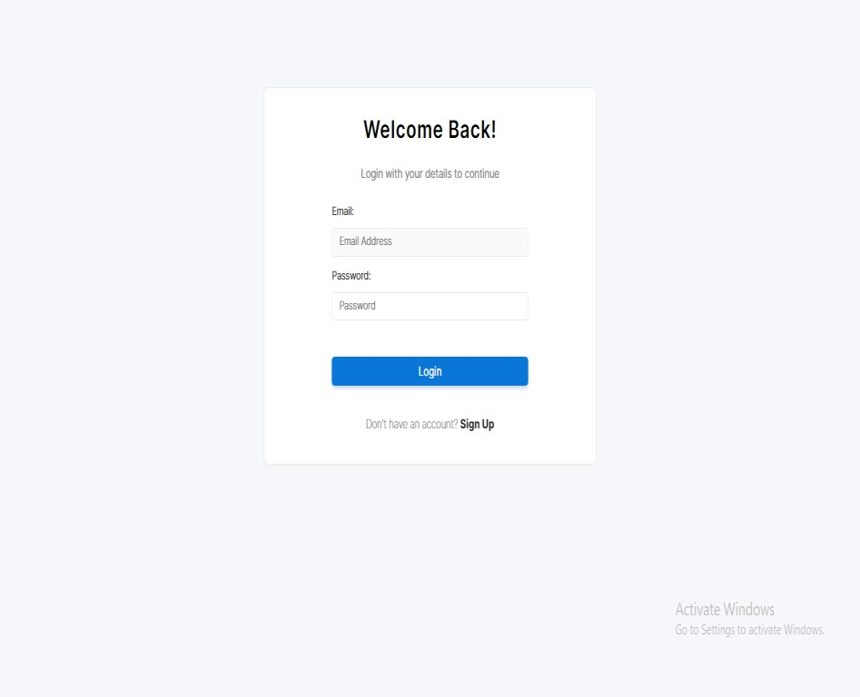

**ADMIN PAGE**

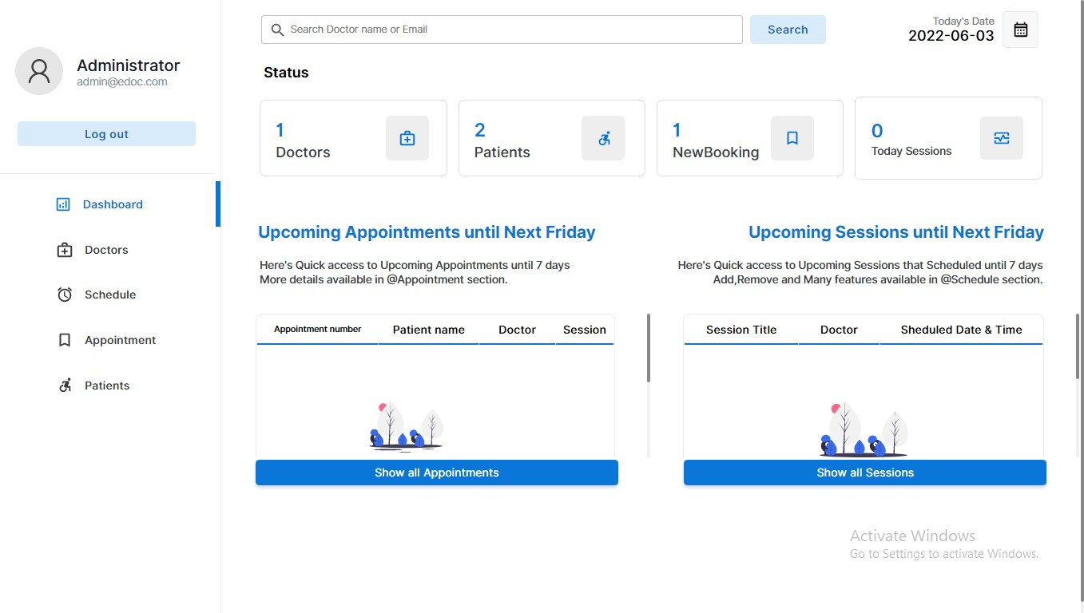

## AVAILABLE DOCTOR

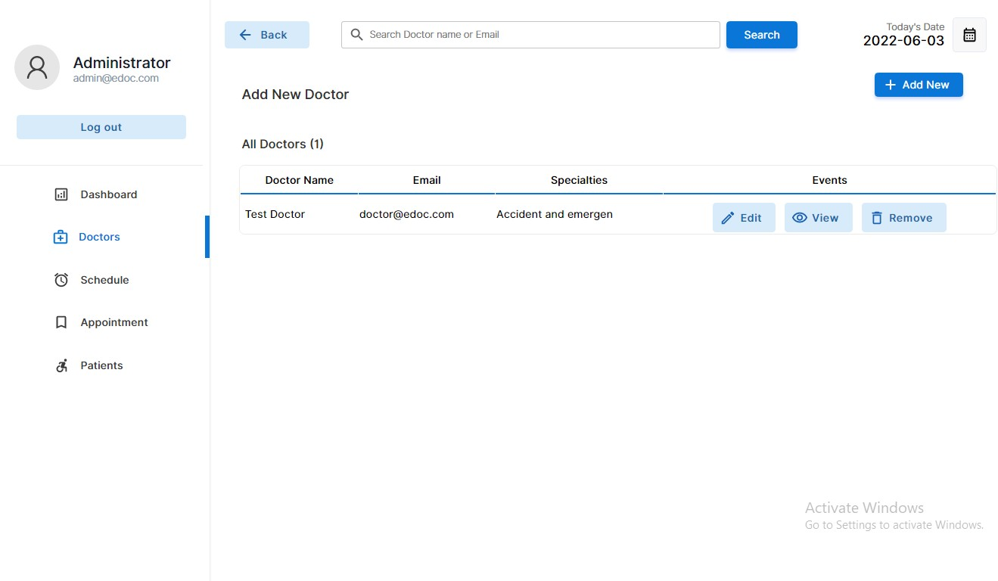

**AVAILABLE SCHEDULE**

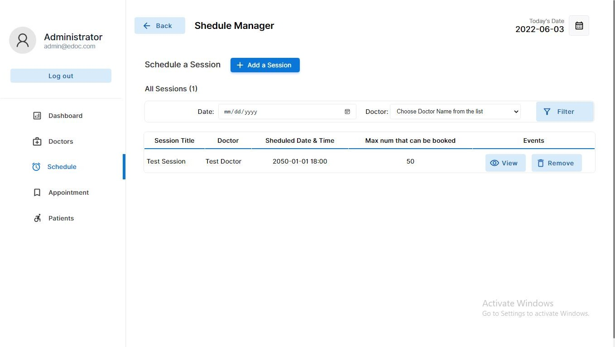

## PATIENT PAGE

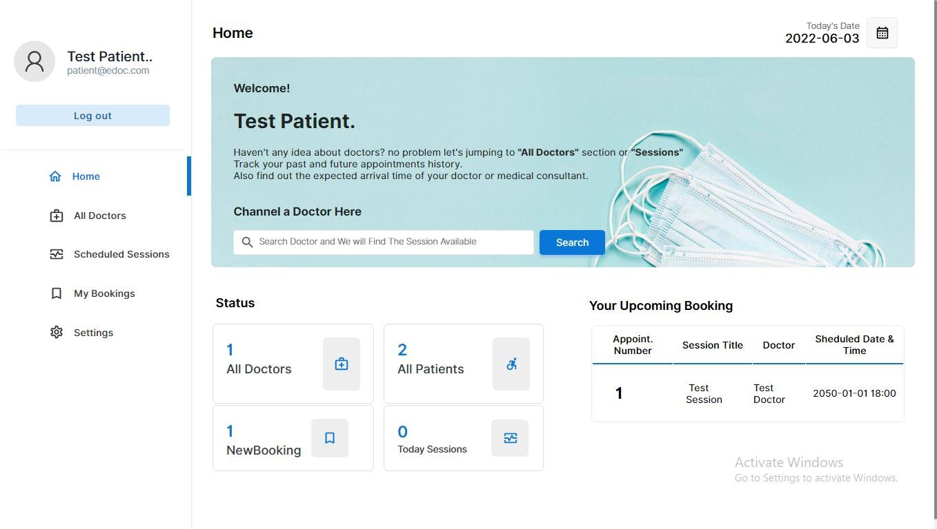

**BOOK APPOINTMENT**

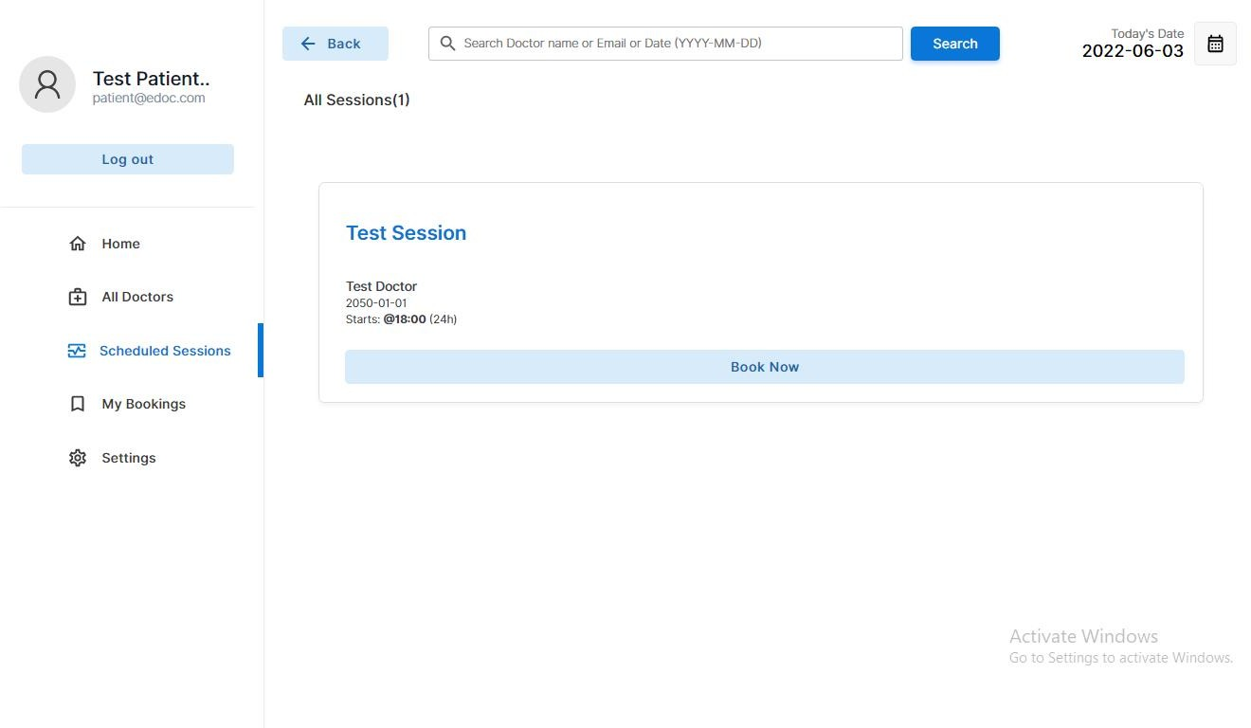

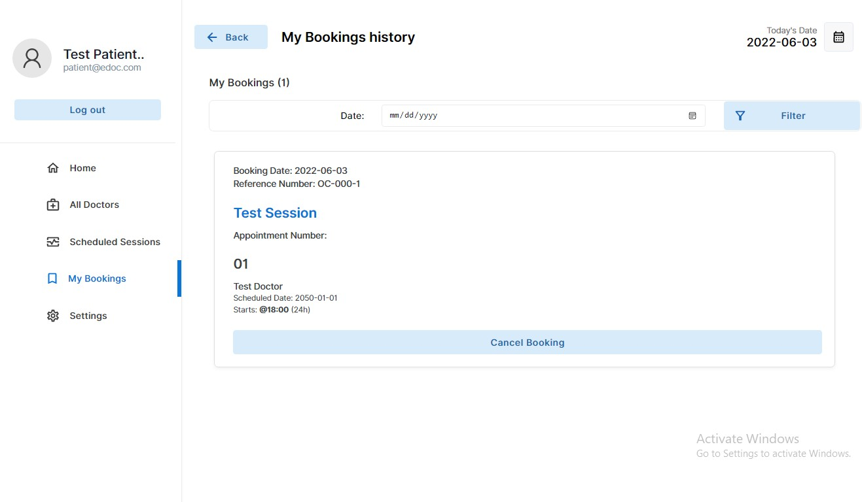

## DOCTOR PAGE

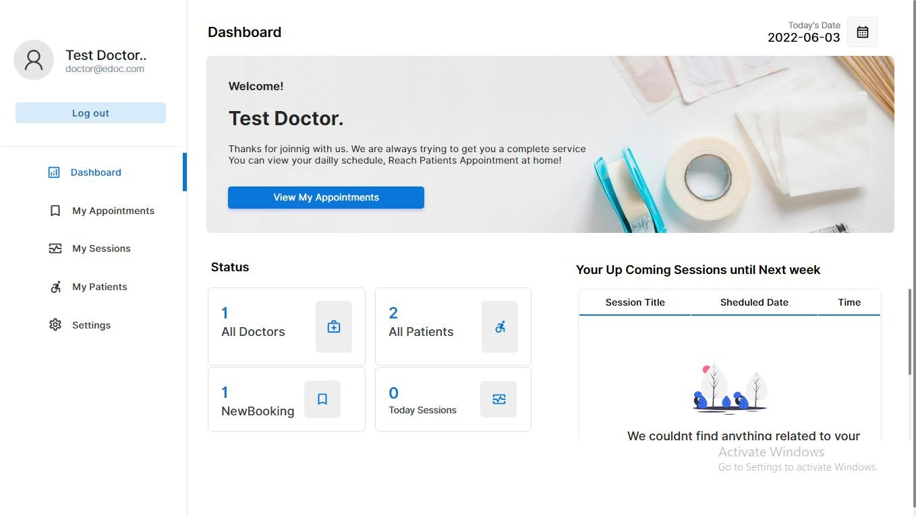

**DOCTOR SETTING**

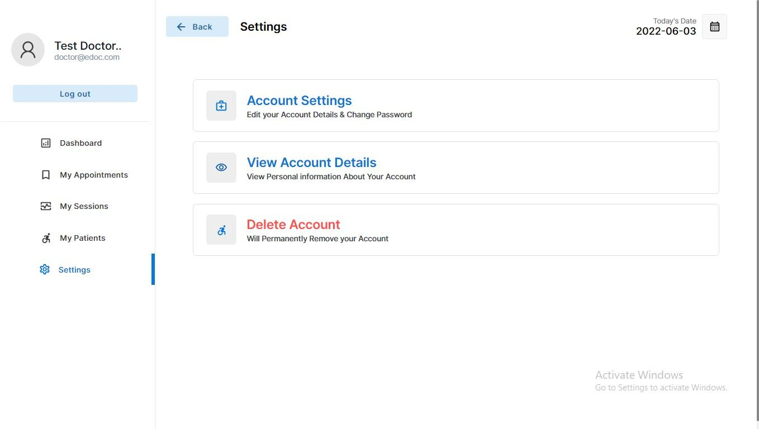

# Conclusion:

* This “online doctor appointment and EMR report” helps in customizing the appointment system and health traking system very easy and convenient
* This system helps in taking appointment at a distant and detail online via mobile and desktop
  + This system helps solving the long waiting for appointment with doctors and keeping the file of prescriptions and report

the get lost many time

* + This system helps in our busy life taking appointments and keeping health record in easy and in best safe way
* User can see the schedule data , time and serial no .doctor can see how much appointment he get for a specific day .
  + Patients are able to book and manage their own appointment with ease. This system helps in taking appointment at a distant

and details online via mobile .

# Future scope

* + Seamless integration with electronic medical records system.
  + EMRs store patient health information , medical history , and treatment plans , allowing doctors to across and update

relevant data during virtual consultations .

* Advancements in Telemedicine , AI driven scheduling system

, personalized health apps , and improved patient doctors

communication platform to enhance accessibility and efficiency in healthcare service .

**ADVANTAGES:**

1.It saves time and money of the doctors 2.Effective and reliable communication 3.High productivity

4.Breaks geographical barriers with patients 5.Increases service quality

6.Improves patients retention 7.Less paper work 8.Contactless diagnosis 9.Easy transactions

## SCOPE:

1. In computer system the person has to fill the various forms and number of copies of the forms can be easily generate at a time
2. In computer system it is not necessary to create the manifest but we can directly print it which saves our time
3. It satisfy the user requirement
4. Be easy to understand by the user and operator
5. Be easy to operate
6. Have a good user interface
7. Be expandable
8. Delivered on schedule within the budget
9. The system generates types of information that can be used for various purposes
10. To utilize resources in an efficient manner by increasing their productivity through automation **.**

### GITHUB LINK:

**PROJECT LINK:**

<https://github.com/visali122/MedAppointments>

### OUTPUT LINK:

**Deployment link:**

<https://visali122.github.io/MedAppointments/index%20(1).html>

### Browse the Doctor's Appointment System in a browser.

<http://localhost/MedAppointments-main/index%20(1).html>

### VIDEO LINK :

[https://drive.google.com/file/d/1yP1Qp7bm4LStLrBKhHm47JD_qzU3Eh9y/](https://drive.google.com/file/d/1yP1Qp7bm4LStLrBKhHm47JD_qzU3Eh9y/view?usp=drivesdk) [view?usp=drivesdk](https://drive.google.com/file/d/1yP1Qp7bm4LStLrBKhHm47JD_qzU3Eh9y/view?usp=drivesdk)

## REFERENCES:

[https://www.youtube.com/playlist?list=PLHmESvg2HbgcnKfLCpz](https://www.youtube.com/playlist?list=PLHmESvg2HbgcnKfLCpzZSUp7tfTI2d_pi) [ZSUp7tfTI2d_pi](https://www.youtube.com/playlist?list=PLHmESvg2HbgcnKfLCpzZSUp7tfTI2d_pi)

### APPENDIX SAMPLE SOURCE CODE

**ADMIN**

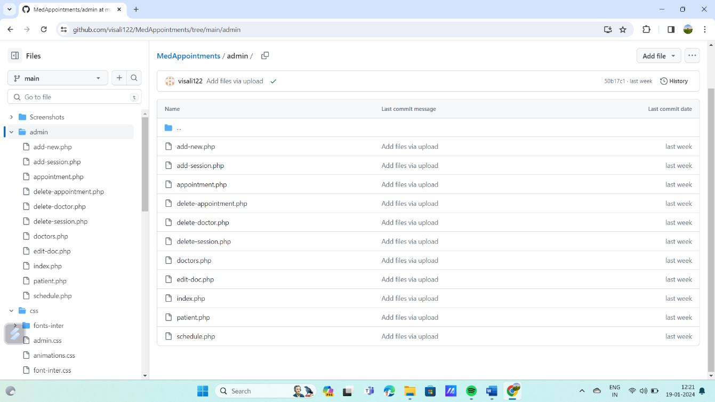

### DOCTOR

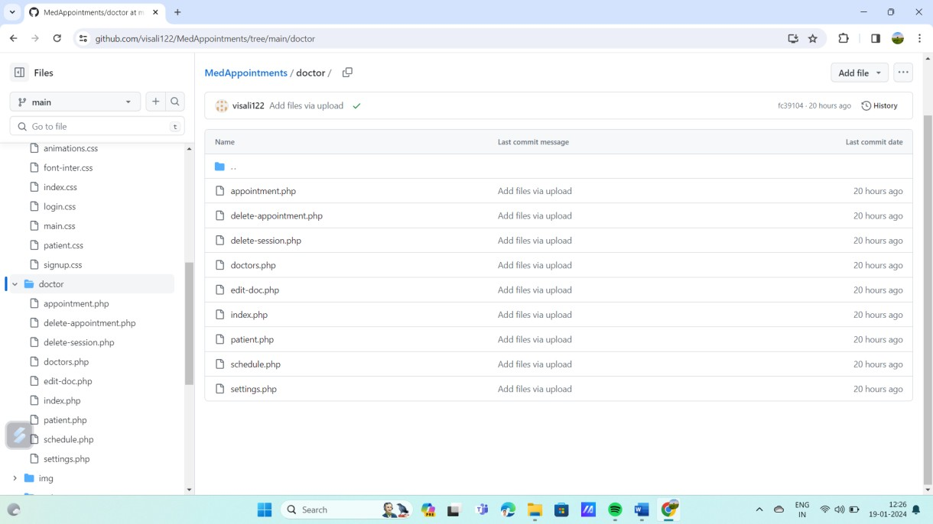

**PATIENT**

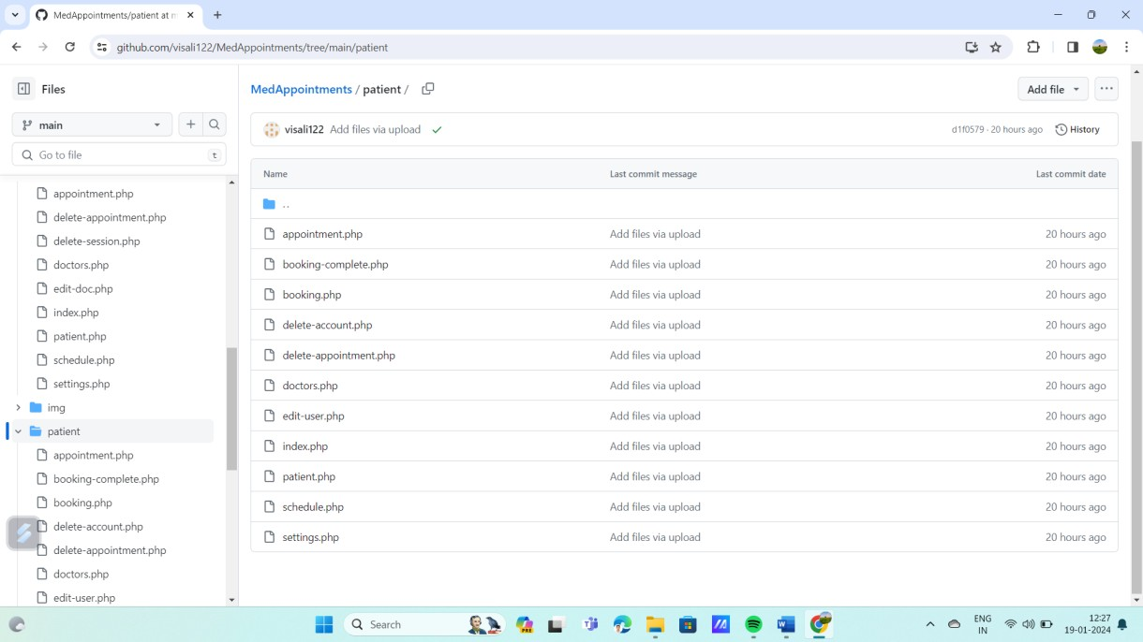

### CSS

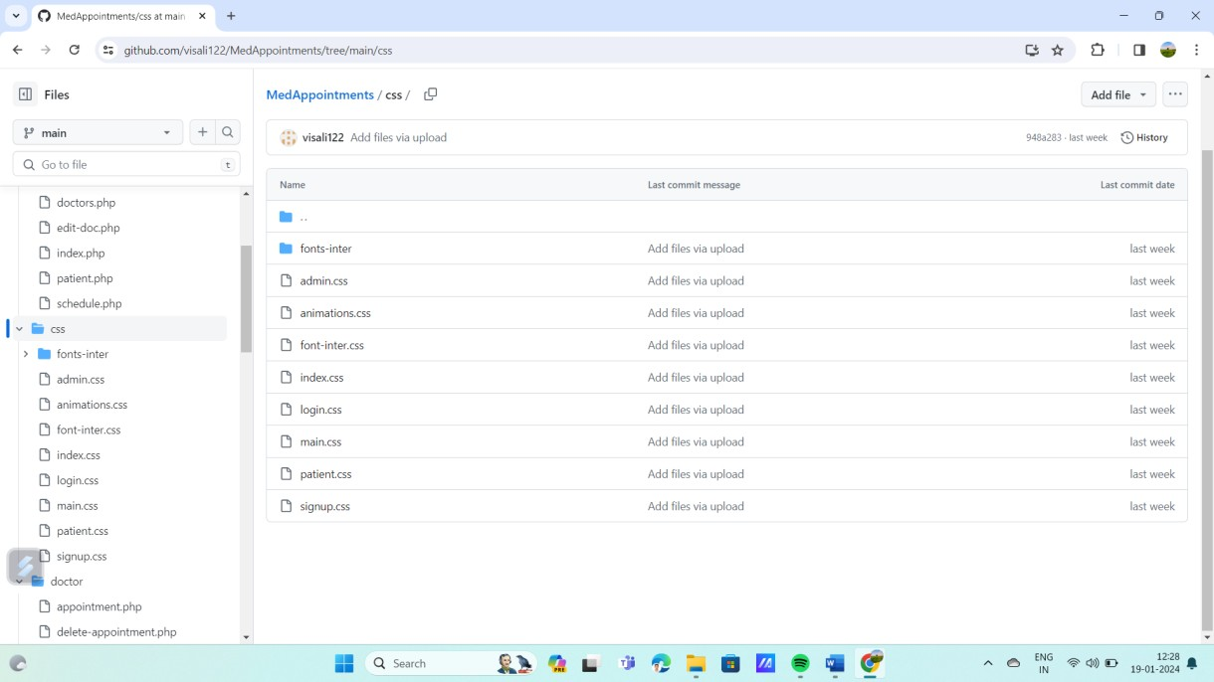

**SQL**

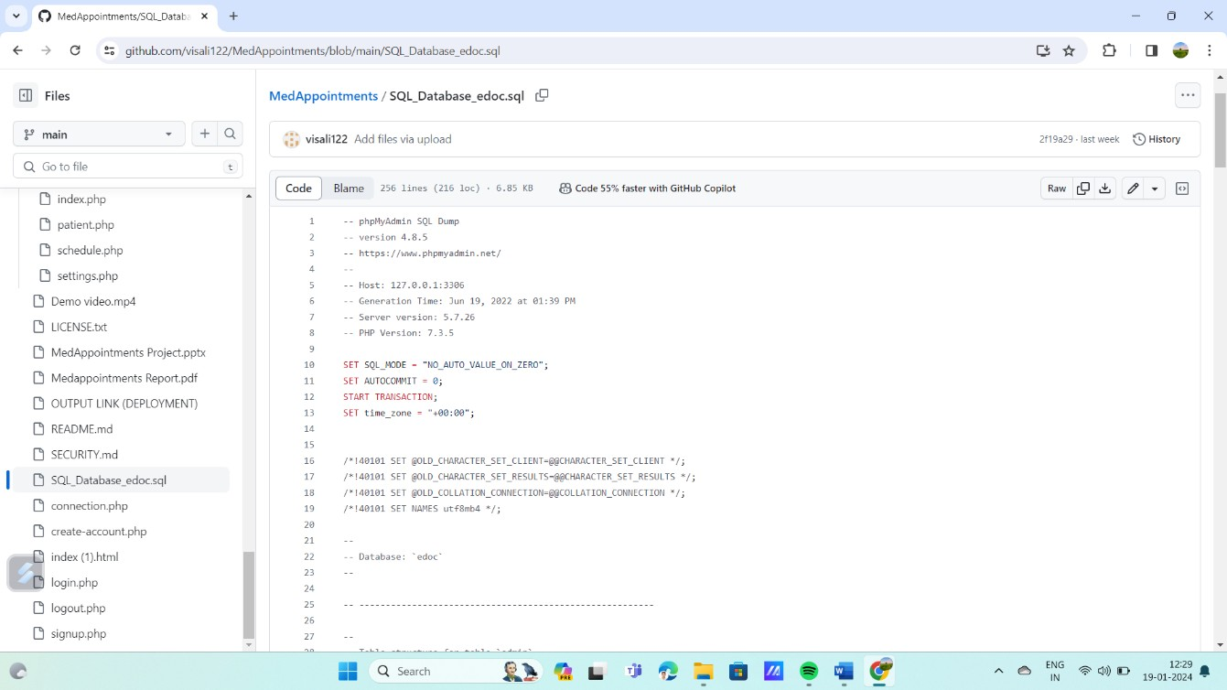

### LOGIN

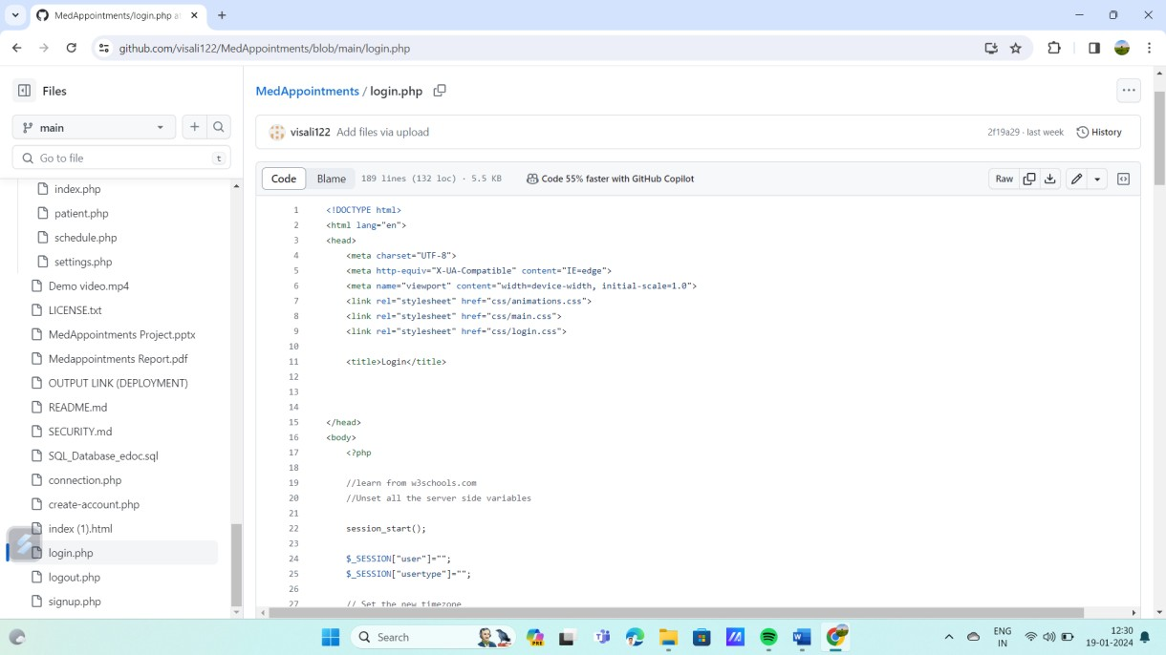

**LOGOUT**

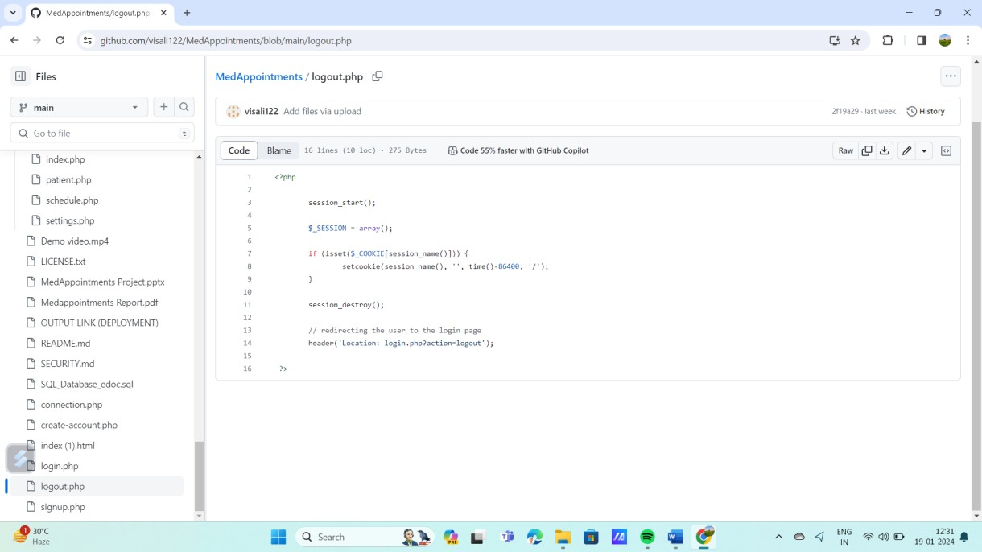

### SIGNUP

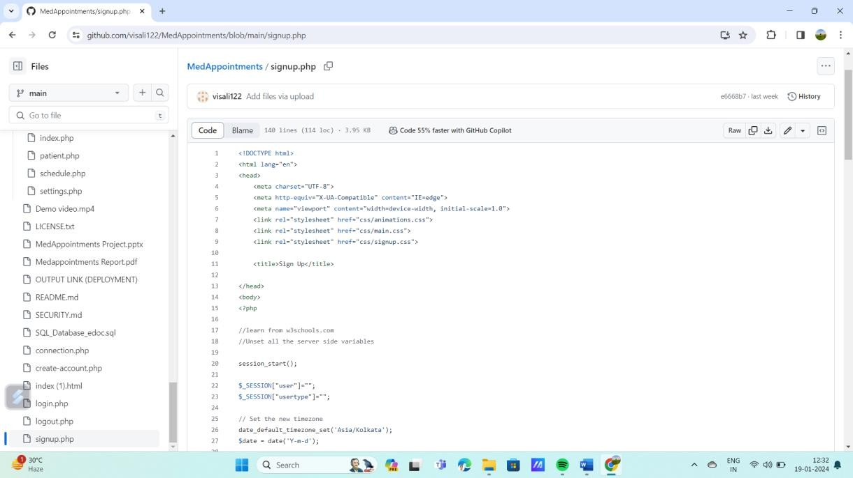

**INDEX(1).HTML**

